GoldenAngle Stack-of-Stars reconstruction README v1.0

Acquiring a dataset
TO DO: describe patch settings
Reconstruction
Be sure to add MRecon, BART toolbox and the Golden Angle paths to your matlab search path!
A reconstruction can be started with the command: GoldenAngle();
You will be asked to pick the .raw file to reconstruct, and a 3D measurement of the full dataset will be reconstructed and saved as a Nifti. A .txt file will be saved in the same locations, listing the parameters used for reconstruction.
You can specify options in a structure parameter P, and start the reconstruction with GoldenAngle(P);
An MRecon output MR, and a full parameter list P can be ouput: [MR,P]= FullRecon_SoS(P);
List of optional parameters
P.folder full path of folder where raw files are located (include / at the end)
P.file filename of .raw scan file
P.resultsfolder full path of folder where results should be saved (standard P.folder/Results)
P.coil_survey filename of .raw coil_survey file
P.sense_ref filename of .raw sense_ref file

P.recontype '3D'; 'DCE'; '4D' (standard:3D)

P.sensitivitymaps true/false; use of sense maps for coil combinations (standard false)
P.sensitvitymapscalc way of calculating sensitivity maps: sense (standard)/espirit
P.dynamicespirit true/false (for 4D/DCE), estimates maps from frame data instead of all data

P.channelcompression true/false: standard false
P.cc_nrofchans number of channels used for compression
P.spokestoread vector specifying channel numbers to use (standard:all)
P.channelstoread vector specifying spokes to read (standard:all)
P.reconresolution vector of matrix size (x,y,z) (buggy)

P.binparams %structure of parameters to use for binning when using 4D reconstruction (see README)

More info on some parameters:
P.sensitivitymaps
False: sum-of-squares will be used for coil combinations (standard)
True: sense maps will be used for coil combinations

P.sensitvitymapscalc
‘sense’: sense maps will be calculated from measured coil_survey and sense_ref scans. If these are not provided in P.coil_survey and P.sense_ref, you will be asked to specify the files. (standard)
‘espirit’: sense maps will be calculated from the center of k-space

- If yolu do a dynamic reconstruction (4D/DCE) you can choose to make sensitivity maps based on the frame-data only. This option can be done with the option P.dynamicespirit=true

P.recontype
‘3D’: all the spokes in the datasets will be used to reconstruct one dataset. (standard)
‘4D’: A retrospectively gated 4D reconstruction with a CS TV constraint will be used
‘DCE’: A specified number of spokes will be used per frame. Reconstruction used CS with a TV constraint.
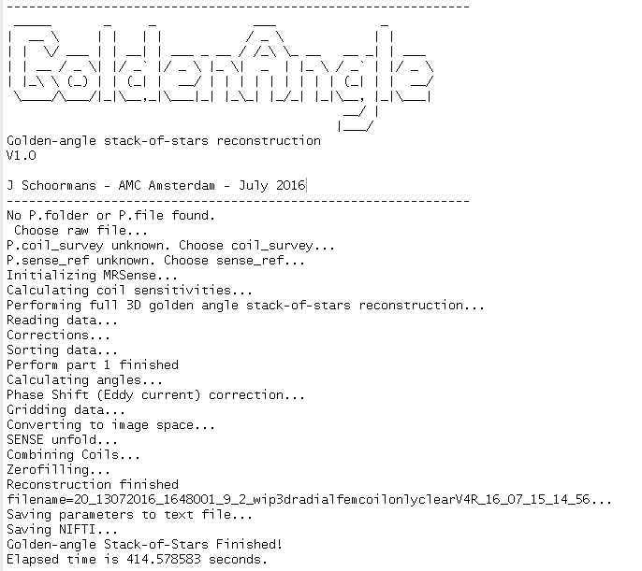

4D BINNING
The function ksp2frames() has many different options for binning of a signal for 4D reconstructions. This can be used stand-alone or in combination with FullRecon_SoS().
In this case, the relevant parameters should be put in the struct P.binparams. Note that when using this function in combination with FullRecon_SoS; many of these parameters will be already set. However, many can optionally be changed to suit your needs.
params.gatingchans: channels to use in self-gating
params.gatingmethod= 'ZIP' / 'PCA'other sorting methods
params.goldenangle : angle (in degrees) used for acquisition
params.smoothingmethod: 'smooth';'none';'filter'
params.filtertype= 'band-pass'/'low-pass'/'band-stop'
params.smoothspan=5; value for MA-filter
params.visualize: 1=on; 0=off
params.minpeakdistance=4 minimum distance between peaks in the gating_signal
params.sortingmethod='v' method of sorting the gating_singal: p=phase; v=value, p2=phase (2)
params.nBins=6; number of bins in which to sort the k-space
params.Fs: sampling frequency (Hz)
params.plotZIP: 1 for test to see best ZIP channel
params.PCAfreqband=[0.5 1] frequency band in which you expect your gating signal (for PCA) (in Hz)

Example parameters for a 4D reconstruction:
P.recontype='4D';
P.binparams.sortingmethod='p2'
P.sensitivitymaps=true
P.sensitvitymapscalc='espirit'
P.binparams.gatingmethod='PCA'
P.binparams.PCAfreqband=[0.2 0.5]
P.binparams.smoothingmethod='smooth'
P.binparams.smoothspan=25;
P.binparams.nBins=16;
P.dynamicespirit=false;

